ESP-01S Relay v1.0

1. Description

This ESP-01S Relay based on AI-Thinker ESP-01S WIFI module. It is designed for smart home, Internet of thing and others DIY project. With this smart relay, you will easy to DIY your smart switch to control any device by your phone anywhere. We support the APP and LUA source code.  
We had upload a demo code in the ESP0-01S, just supply a DC5V power, then you can control it.

In the version, we use the GPIO0 of ESP-01S to control the Relay by Hight level.

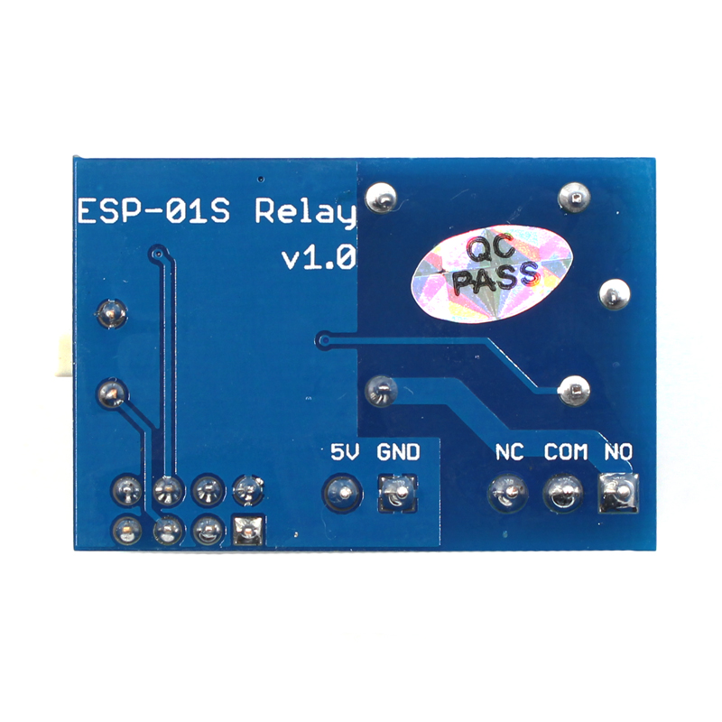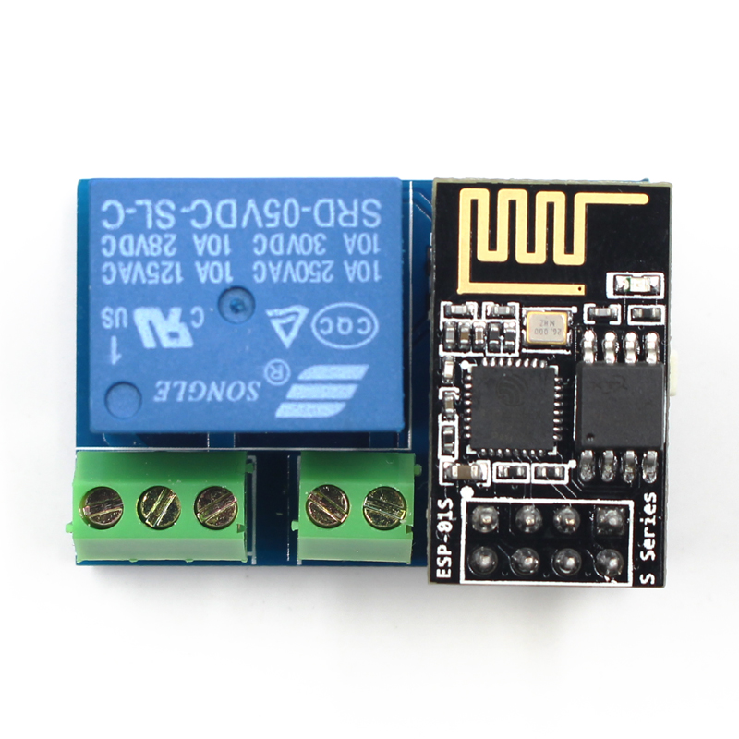

1. Schematic

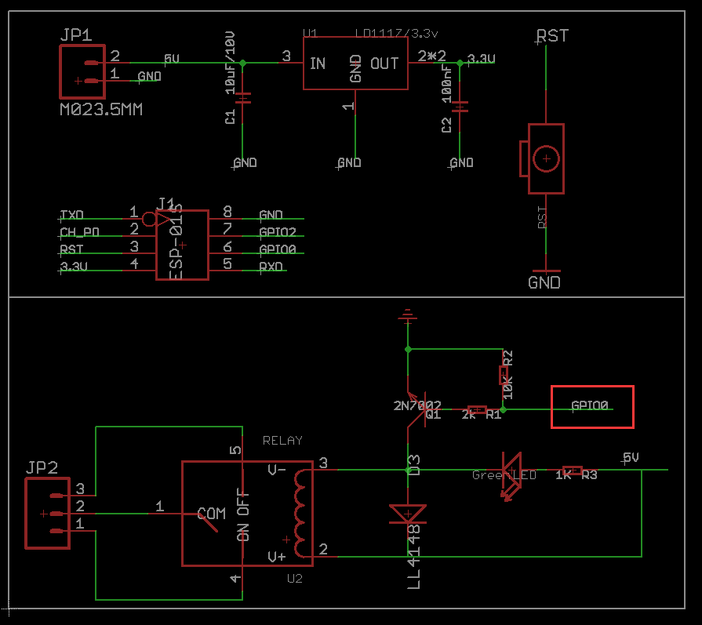

1. **Parameter**

*Working voltage: DC5V

*Working current: ≥250mA

*Communication: ESP-01S WIFI module

*Transmission distance: the maximum transmission distance of 400m (open environment, mobile phone equipped with WIFI module)

*Load: 10A/250VAC 10A/30VDC, the relay pulls 100,000 times

*GPIO0 of ESP-01S Control the Relay (High level active)

*Product size: 37 * 25mm

1. Usage
2. Hardware connection

Just plug the ESP-01S to the 2*4 pin header after download the code to ESP-01S. Show as below:

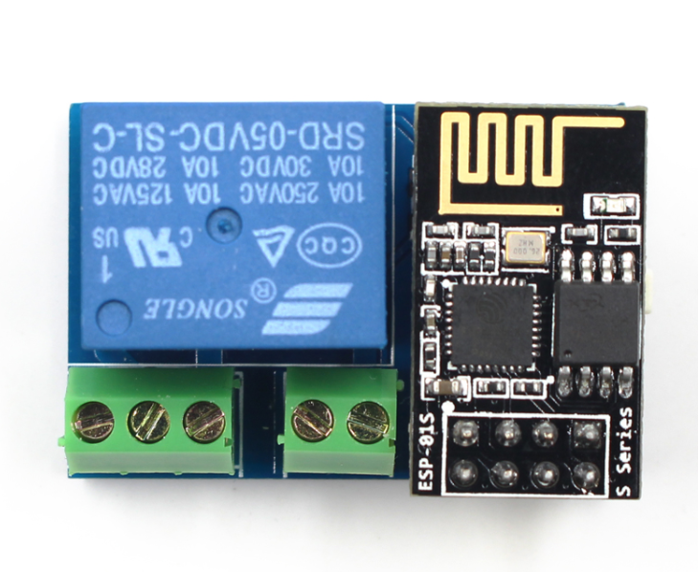

1. Power supply

Connect a DC 5V power to the GND and VCC.

1. **Open your phone WLAN then connect the WiFi ESP8266-XXXX, Power word:12345678**
2. **Open the ESP8266 Controller.app ( Installed it in your android phone before)**
3. **Set IP Address: 192.168.1.1 than you can control your device via the wifi relay module:**

